

1 ) on click open popup

2)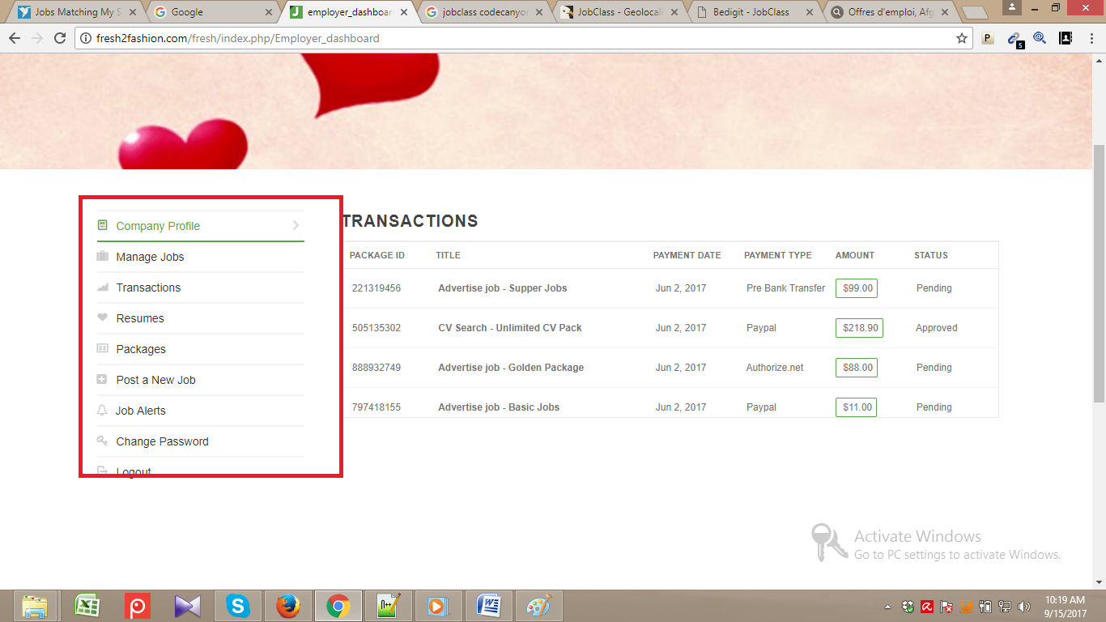

On click selected that potion

3) 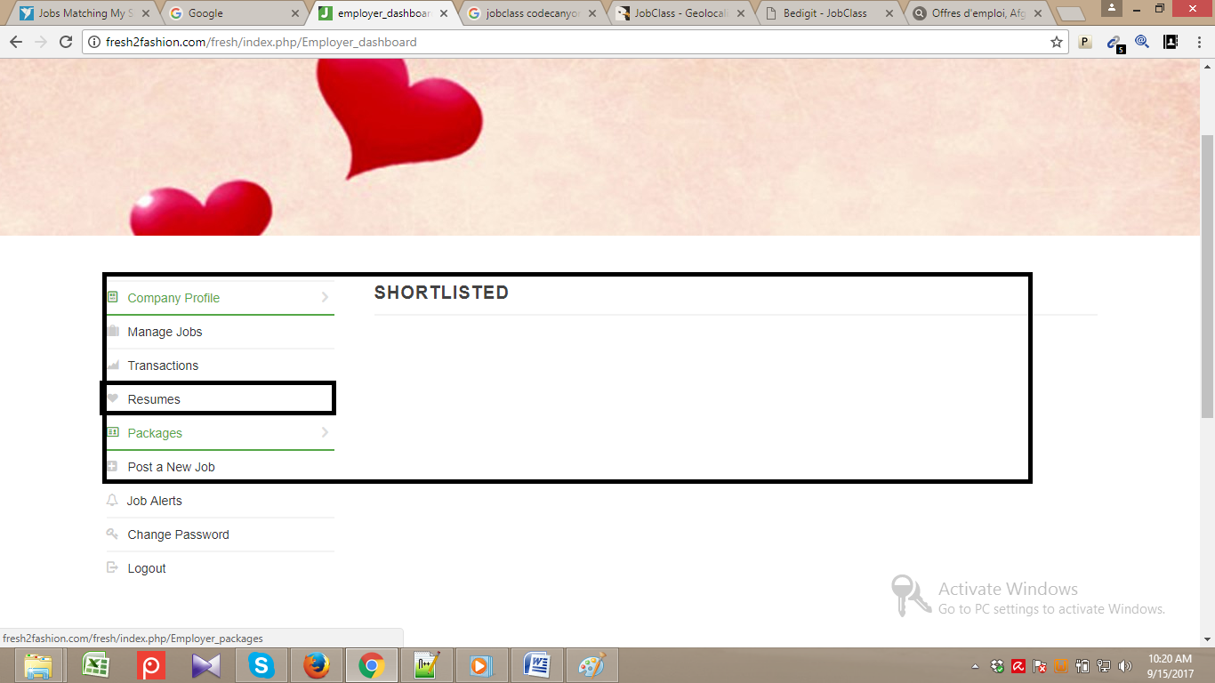

On click resume not display any thing

If data not available then show msg Data Not Found